**Project Design Phase-II**

**Data Flow Diagram & User Stories**

| Date |  |
| --- | --- |
| Team ID | LTVIP2025TMID21184 |
| Project Name | Freelance Finder |
| Maximum Marks | 4 Marks |

**Data Flow Diagrams:**

A **Data Flow Diagram (DFD)** illustrates how data moves within the Freelance Finder platform. It captures how users (freelancers and clients) interact with the system, how information flows between different components, and where the data is stored.

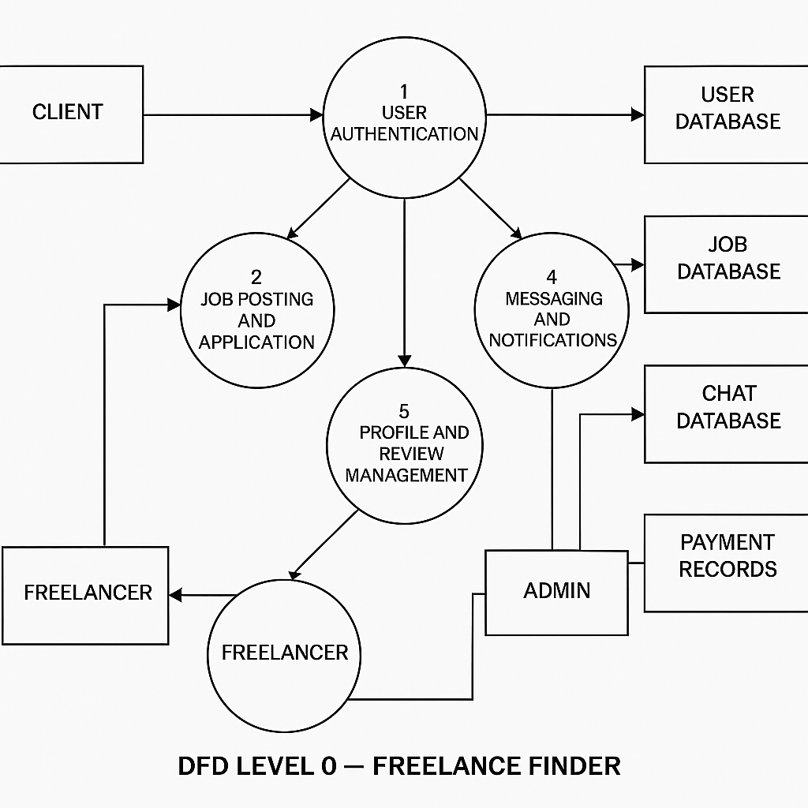

**User Stories**

**User Story Table – Freelance Finder**

| **User Type** | **Functional Requirement (Epic)** | **User Story / Task** | **Acceptance Criteria** | **Priority** | **Release** |
| --- | --- | --- | --- | --- | --- |
| **Client** | |  | | --- |  | Job Posting | | --- | | As a client, I can post a new freelance job. | Job appears on homepage and my dashboard. | High | Sprint-1 |
|  | |  | | --- |  | Job Browsing | | --- | | As a freelancer, I can browse and filter available jo | Filter returns relevant results. | Medium | Sprint-2 |
| **Freelancer** | Job Application | | As a freelancer, I can apply to a job with a proposal. | | --- | | Application visible to client. | High | Sprint-1 |
| **User** | Messaging | As a user, I can chat with the other party in real-time. | Messages appear instantly. | Medium | Sprint-2 |
| **Freelancer** | Profile Management | As a freelancer, I can update my profile and portfolio. | Changes are saved successfully. | High | Sprint-2 |
| **Client** | Payment Processing | As a client, I can make secure payments after job completion. | Payment recorded and shown in transaction history. | High | Sprint-2 |
| **user** | |  | | --- |  | Review System | | --- | | As a user, I can leave a review after project closure. | Review appears on profile. | Medium | Sprint-2 |
| **Admin** | User Moderation | As an admin, I can review reported users and take action. | Reports and actions logged. | High | Sprint-1 |